Basketball Scoresheet:
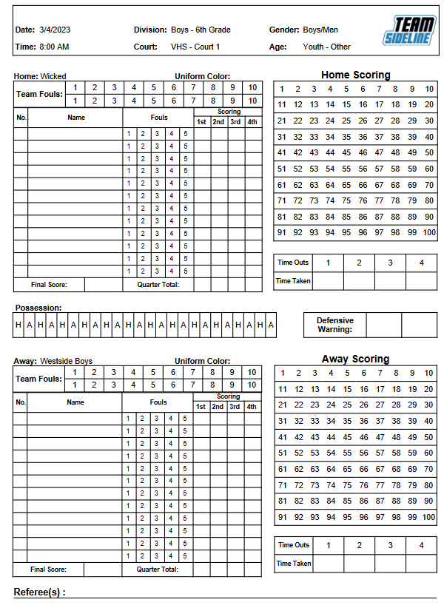
Basketball Scoresheet – 2 pages – home/away on different sheets:
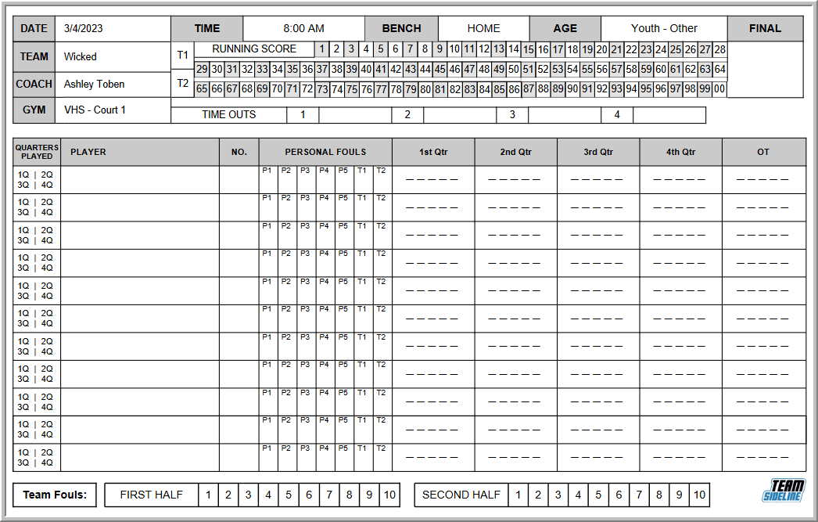

Basketball Scoresheet Version 2:
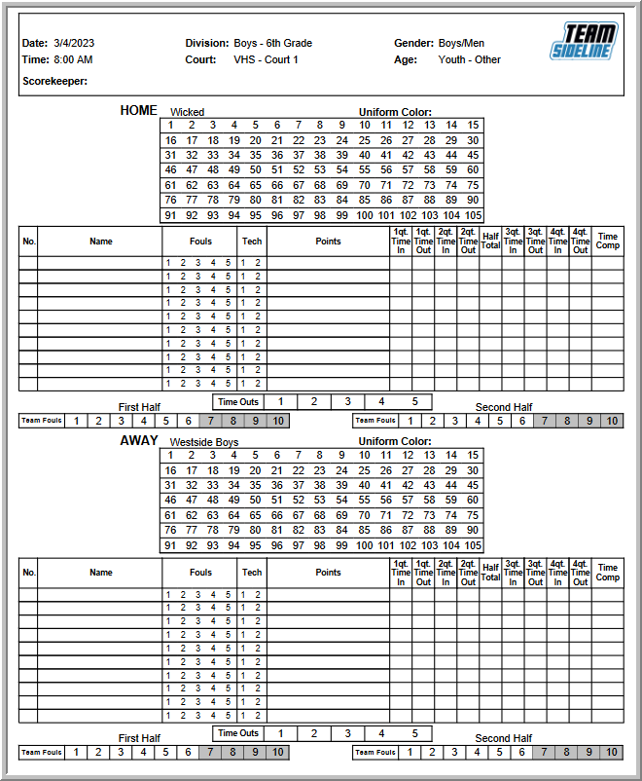

Basketball Scoresheet Version 3:
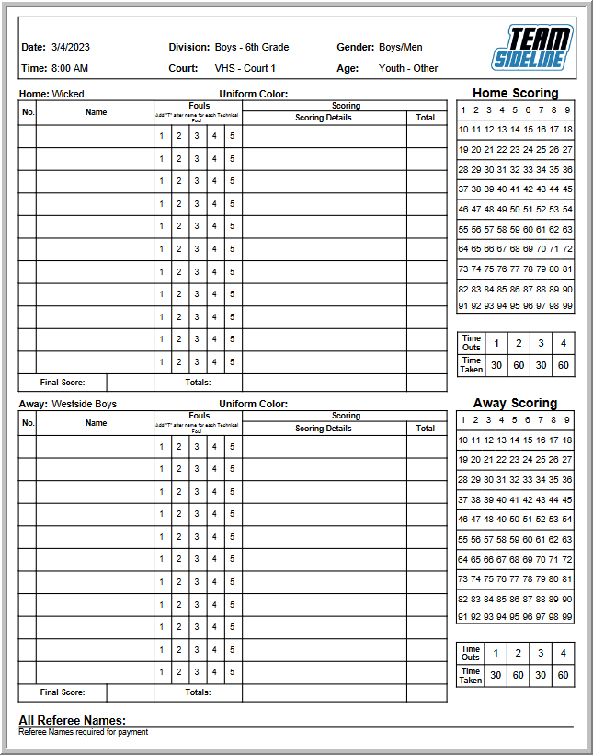

Basketball Scoresheet with 8 Periods:
